- 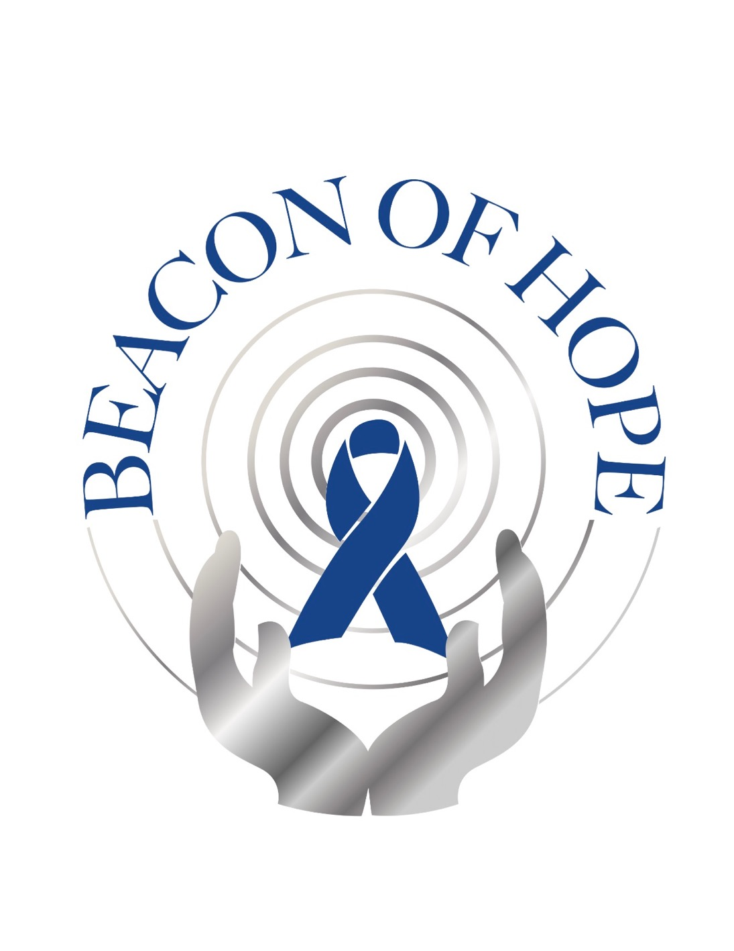
2018 BEACON OF HOPE 5K RUN
IN MEMORY OF KEVIN P. ENTERLEIN

Sunday November 18, 2018
Tiger Shark Cove Park, Wellington, FL 33414

VENDOR OPPORTUNITIES

Name:______________________________________
Address:____________________________________
City/State/Zip________________________________
Email:______________________________________

All vendors will be supplied tables and Chairs. Any promotional materials/equipment is the vendors
responsibility. To be responsible to set-up and remove what they came with. Respecting the Village of
Wellington. Must arrive between 5:30-6am to set up. Wellington streets will be closed off after certain time.

